Circularity Toolkit: E-waste Blueprints
E-waste Processor Pack
A guide to selecting and manging recycling partners for OGS companies
About the Circularity Toolkit: E-Waste Blueprints:
GOGLA, with the support of Swedfund, has developed these E-waste Blueprints as part of our Circularity Toolkit to help off-grid solar companies implement and improve e-waste management across their operations.
The Blueprints build on the knowledge and best practice identified in phase 1 of our Toolkit. Wherever possible, we have sought to ensure that the Blueprint documents are applicable to a broad cross-section of OGS companies, regardless of company stage, product type or country of operations. However, companies should adapt the Blueprints as necessary to their individual operational context.
Acknowledgements:
GOGLA is grateful to Swedfund for funding the development of the E-waste Blueprints and for their continuous support to GOGLA's ambitions to improve standards of e-waste management in the off-grid solar industry.
The Blueprints were developed by Sofies, in collaboration with Akinyi Chemutai (independent), Charlotte Heffer and Wilson Wambugu (d.light), and Rebecca Rhodes (GOGLA). Thank you also to those companies and members of our Circularity Working Group who were involved in the consultations that helped us to shape the Blueprint elements of our Toolkit.

Table of Contents
1. Introduction 3
2.Process Overview 4
Step 1. Pre-screening 6
Step 2. First site visit and audit 7
Step 3. Review and decision making 8
Step 4. Contracting 8
Step 5. Follow-up site visits and audits. 9
Annex 1: Pre-Screening Document 12
Annex 2: Pre-Screening Checklist for decision-making [INTERNAL] 14
Annex 3: Audit Document 16
Annex 4: Physical Examination Checklist [support for unannounced site visits]. 23
Annex 5: Contract and management templates 25

List of Figures
Figure 1: Procedure Flowchart 4
Figure 2: Pre-screening flowchart 6
Figure 3: First audit procedure 7

Introduction
The e-waste processor procedure pack is intended to guide off-grid solar (OGS) companies through the process of selecting, contracting, and periodically auditing e-waste processing / recycling partners. E-waste processing partners offer end-of-life management services for collection, dismantling, recycling, or disposal.
This pack breaks down the process of selecting and managing an e-waste processor partner into five actionable steps: 1) pre-screening, 2) first audit, 3) decision making, 4) contract drafting & signing, and 5) periodic auditing.
Each step has practical tools and checklists to support and simplify the processes for OGS companies. These Blueprints were designed based on an extensive industry consultation and have been reviewed by e-waste processors serving off-grid markets and OGS companies. The editable templates are thus made to fit the African and Asian context and present realistic standards that can be adjusted according to a country’s legislative framework and the stage or size of the OGS company.
This e-waste processor pack equips the responsible e-waste lead within an OGS company to effectively carry out each stage of the process. The process defined will ensure that you select legitimate and trustworthy partners.
What your OGS company will need:
- The commitment and capacity to follow all 5 steps for the selection and auditing of e-waste processors.
- One person or team to be explicitly responsible for the pre-screening and periodic auditing stages in each country of operation.
- Sufficient background knowledge on the e-waste legal framework in your countries of operation. You can start with the GSMA e-waste legislation map or Global e-waste statistic partnership country sheets.

The five steps are summarised in the flowchart (figure 1) below and detailed in the following sections. The attached procedures and documents can also be used for the auditing of existing e-waste processing partners.

Process Overview
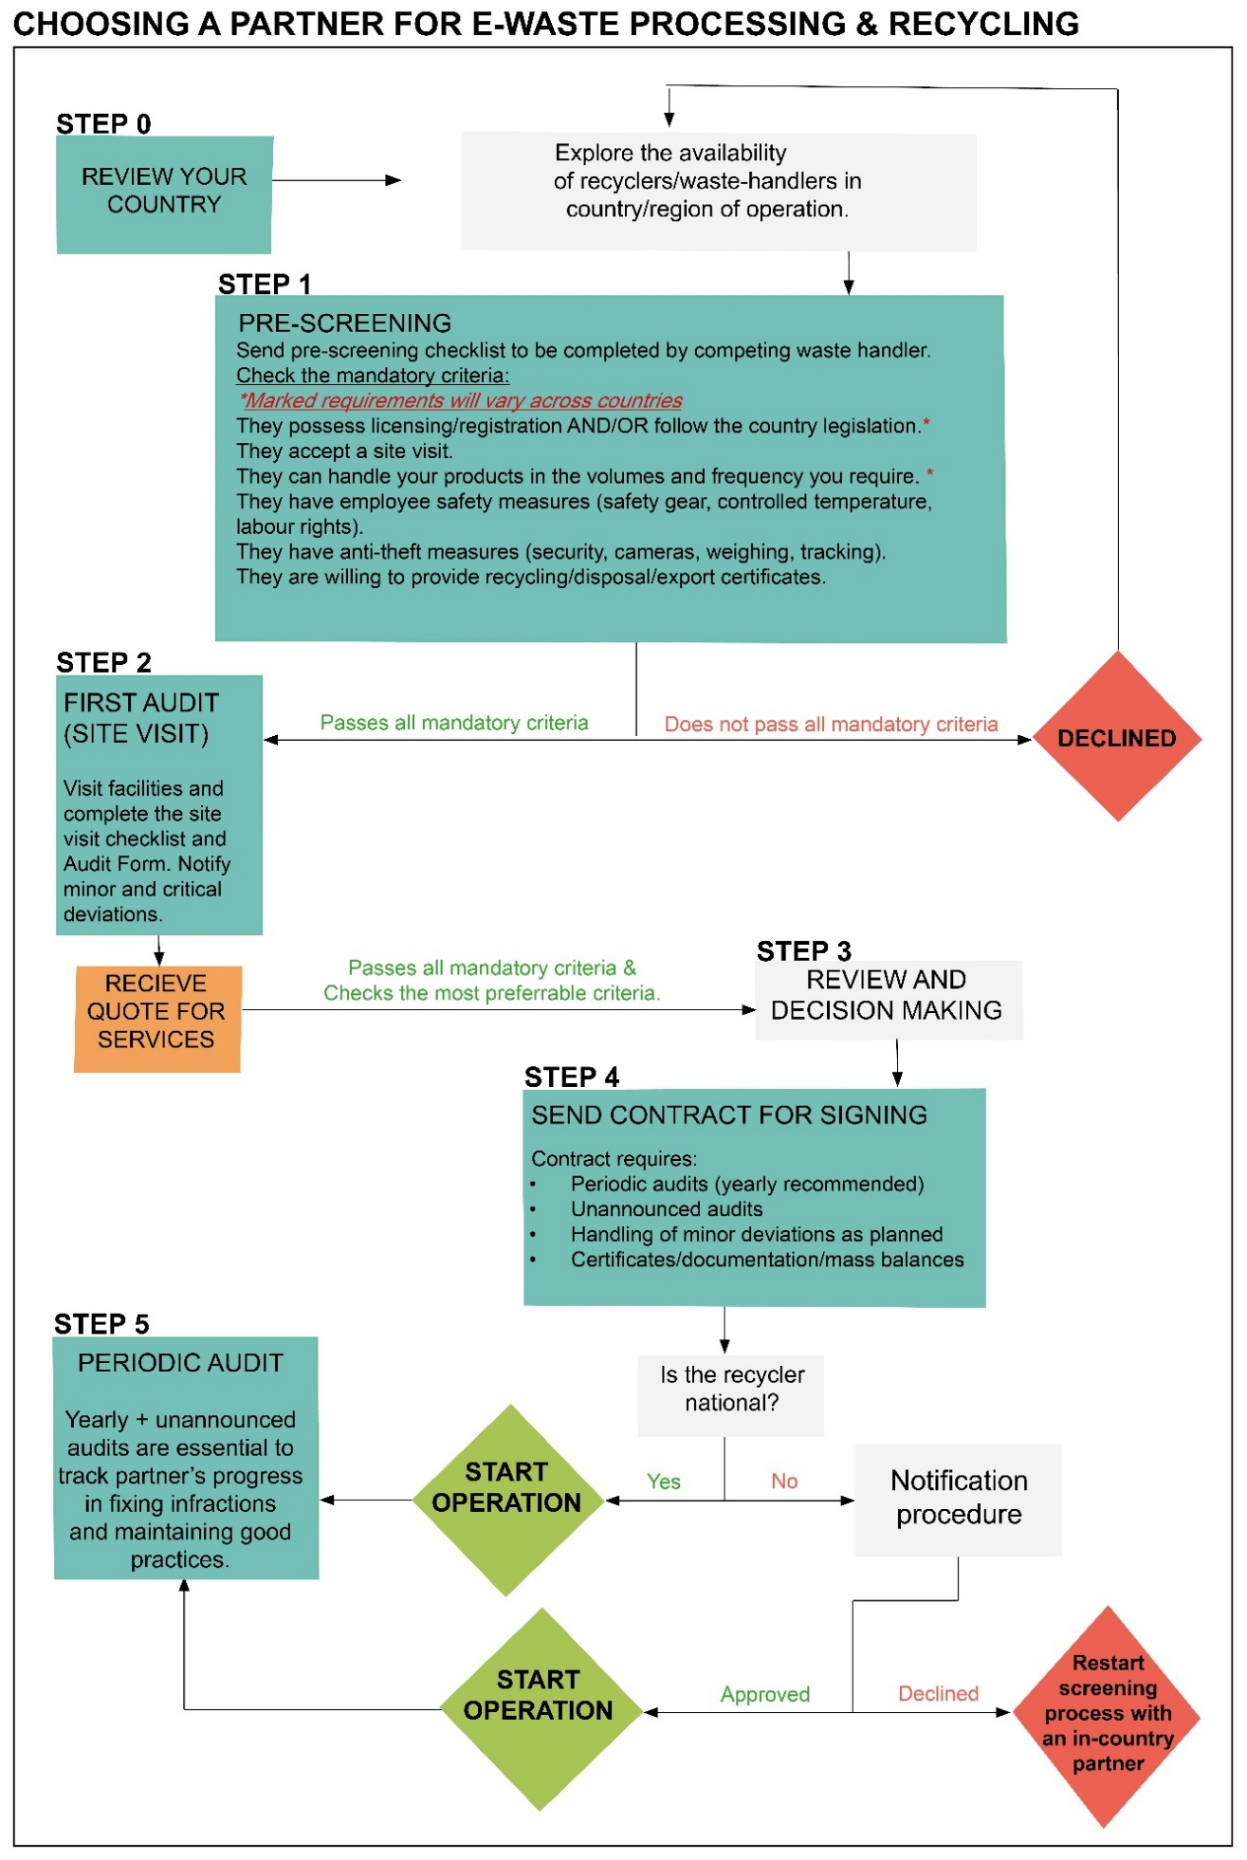
Figure 1: Procedure Flowchart
Note to users: When seeking out new recycling / e-waste management partners, the following resources may be useful:
- GOGLA collates an e-waste service provider catalogue, which is available to GOGLA members here: GOGLA E-waste service providers catalogue
- Reach out to other OGS or electronics companies operational in your market who may have contacts with recyclers. GOGLA members can also use the regional Working Groups to connect with other OGS companies who may have useful contacts.
- Engage your National Renewable Energy Association (NREA), who may have contacts with service providers in the market, or with the relevant government department (e.g., National Environmental Management Authority (NEMA)).
- If you are unable to identify a suitable service provider in your country of operations, recyclers with a regional presence may be able to assist. However, transboundary movement of e-waste is complex and may be restricted. In this situation, review the e-waste landscape every 6 – 12 months until you can identify an appropriate service provider, explore alternative short-term options such as safe landfill, and ensure that you have safe storage facilities available in the meantime.

- Pre-screening
The purpose of pre-screening is to eliminate illegitimate candidates before having to conduct a site visit.
The steps of this initial review include:
- Review and refine the proposed pre-screening form (see Annex 1) and based on local legislation.
- Send the pre-screening form to the service provider and ask them to provide the required information and return.
- Evaluate the returned information with the help of the internal checklist of minimum requirements (see Annex 2).
N.B. Items for which evidence/documentation is not submitted should be considered as non-conforming until proof can be obtained. As necessary, follow up for missing documents.
- Decision:
  - Service provider is approved: meets all minimum requirements in all relevant countries of operation. Proceed to step 2.
  - Service provider is not approved: partner does not meet all minimum requirements in relevant countries of operation. Decline and initiate search for an alternative.

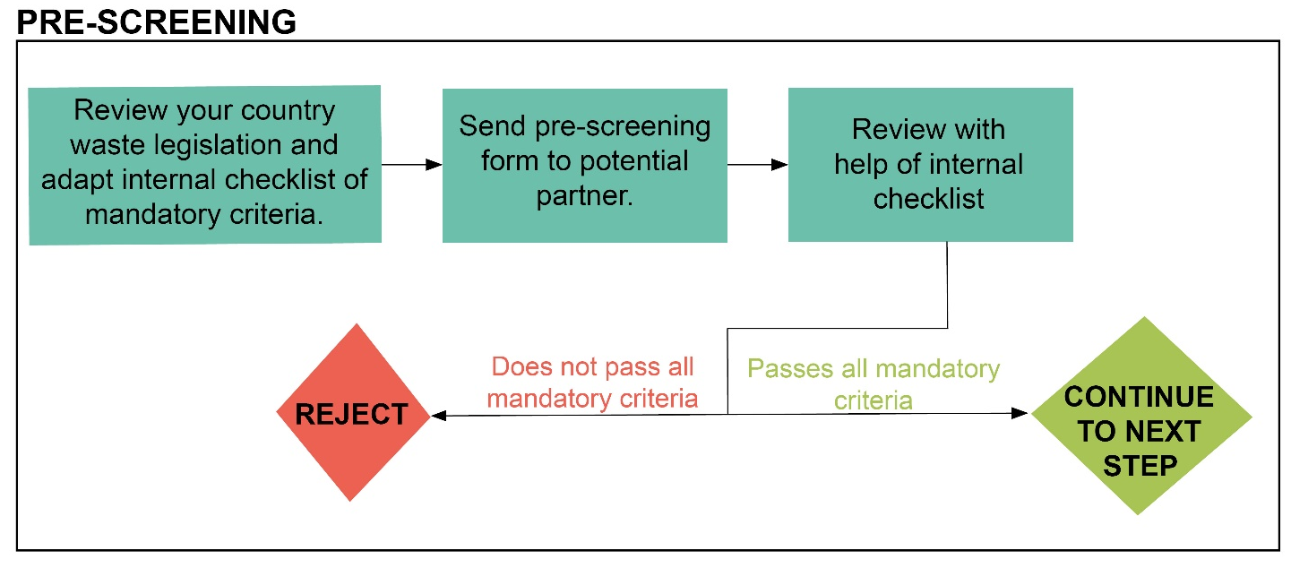
Figure 2: Pre-screening flowchart

- First site visit and audit
After the initial screening of a potential recycling or e-waste processing partner, it is recommended that OGS companies make a visit to the facilities to conduct an audit and verification. In doing so, an OGS company can:
- Verify and ensure the legitimacy of the service provider.
- Verify the responses provided during pre-screening.
- Create a paper trail and proof of due diligence for legal protection.
- Demonstrate the importance given to environmental, health and safety concerns.
The step-by-step process for the first audit is as follows (see figure 3):
- Review the audit form (see Annex 3) and adapt to country legislative requirements and company needs. Review and edit critical requirements list as necessary and appropriate to your internal requirements (critical requirement are highlighted in orange within the audit/checklist Blueprints)
- Arrange a site visit. If more than one service provider passed the pre-screening process, you may wish to visit more than one service provider.
- Conduct the site visit and complete the audit form with the help of the service provider/recycler representative.
- Evaluate the outcome, tallying minor and critical deviations for the service.
It is recommended that and deviation from critical requirement shown in the pre-screening checklist are eliminatory. Other such deviations should be addressed by the service provider, prior to contracting.
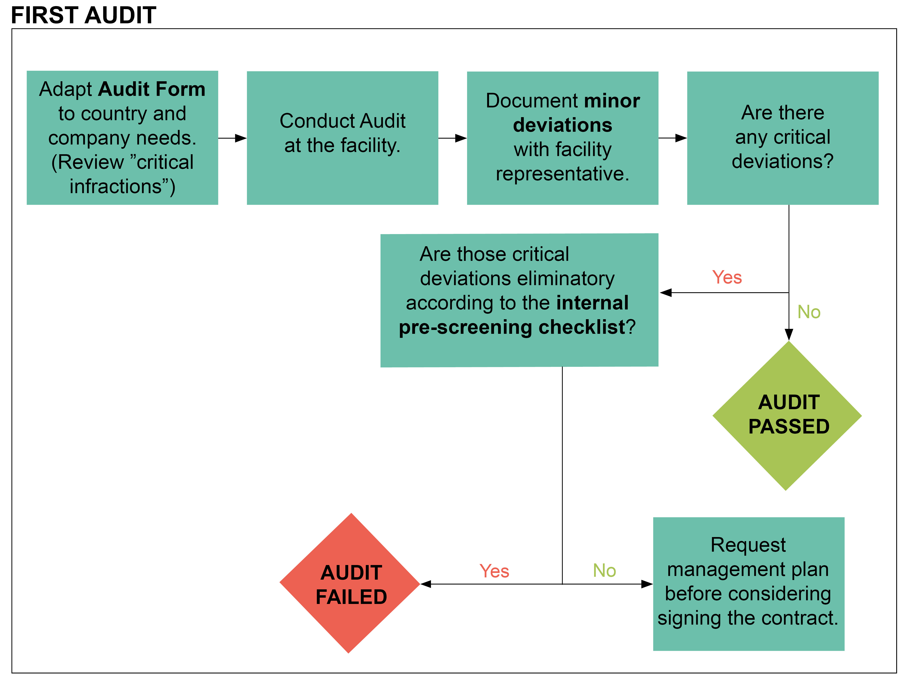
Figure 3: First audit procedure

Review and decision making
If the e-waste/recycling service provider is satisfactory to your requirements (and the recommended standards listed in the annexes provided), you may then proceed to pricing and service evaluation:
- Ask for a quotation from all potential service providers.
- Review the pricing and service offering and assess according to your needs and resourcing.
It is preferrable for a quotation to include:
  - All services (transportation, storage, handling etc.) and associated costs, clearly categorised and itemised.
  - If applicable, all service costs are categorised per product type and/or material (e.g., SHS, Li-ion battery, PV panel).
  - All additional fees and costs, clearly itemised, such as: fee for handling leaking batteries, administrative costs etc.
  - A guarantee that there are no additional, hidden costs (including, for instance, taxes or levies).
- Base your decision on both the audit results (e.g., no deviation from critical requirements, least number of minor deviations) and on costs/service offering.

Contracting
Ensuring that there is a contract in place with the selected e-waste service provider/ recycler will protect the interests of the OGS company.
Contracts need not set minimum e-waste volumes for your company, nor oblige a company to commit minimum quantities. It is recommended that the term of any contract is at least 12 months.
- Review the contract template provided with the E-Waste Blueprints (see link at Annex 5) and adapt to your company needs and country legislation.
- Send the draft contract to the service provider for review and negotiate if needed. It is highly recommended that the contract include:
  - A clause to safeguard for the OGS company in case of illicit behaviour of the recycler.
  - A clear mandate for the recycler to comply with all applicable, national legislation and best practices.
  - An agreement for a periodic audit with a defined schedule, and the right to conduct unannounced site visits.
  - The provision of recycling or disposal documentation such as yearly mass balances (see Blueprint mass balance spreadsheet.) and a notification of safe disposal (see Blueprint notification of se disposal).
  - Sign and begin operations.

Follow-up site visits and audits.
It is recommended that companies conduct annual audits on e-waste service providers, in addition to unannounced site-visits, to ensure conditions remain acceptable and any major deviations from requirements are being appropriately handled.
- For a scheduled audit: use the audit document (Annex 3).
- For an unannounced site visit: use the physical examination checklist (Annex 4). If new breaches are notified, plan a follow-up audit.
During a site visit or audit, the OGS e-waste lead or representative should review any previously identified shortfalls and assess how they have been addressed by the recycler. Any new deviations from expected operational standards should be shared with the recycler who should prepare a plan to rectify.

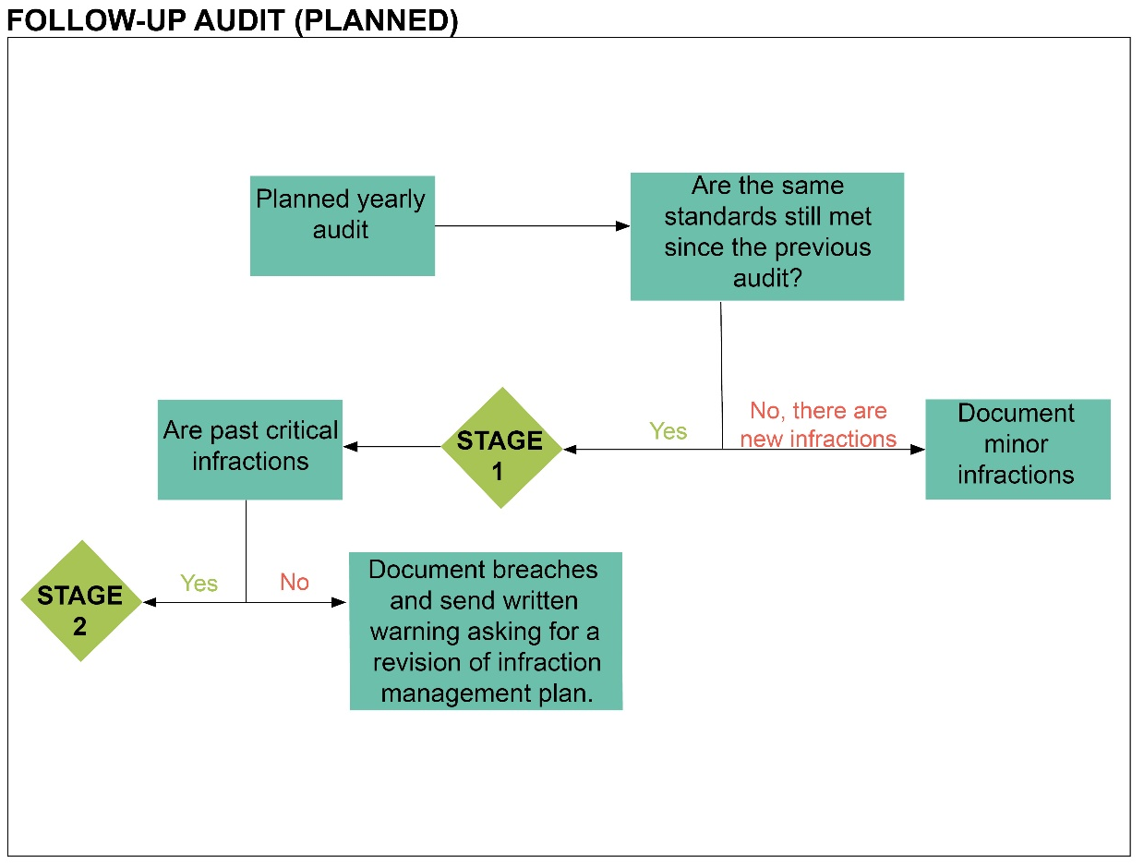

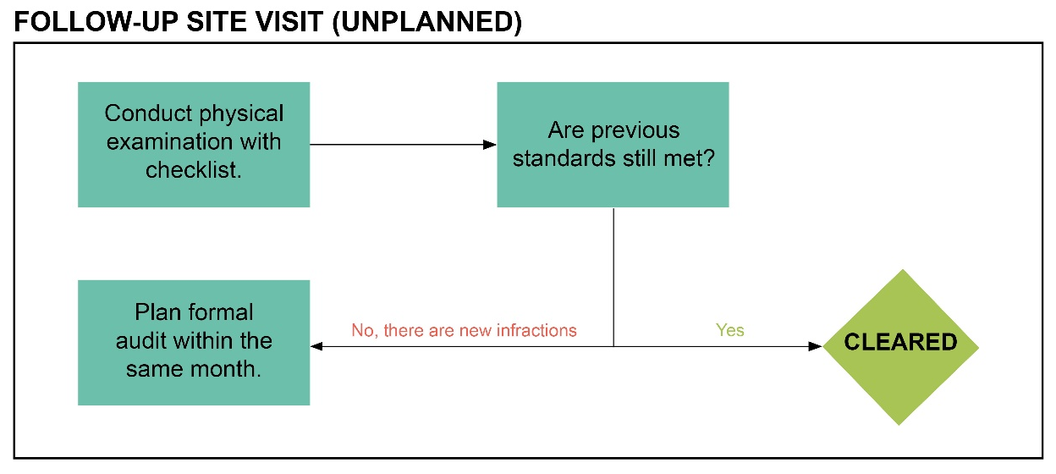
Figure 4: Follow-up Site visits and Audits Flowchart.

Annex
Tools to help you select and manage an e-waste service provider

Annex 1: Pre-Screening Document
AUDIT DETAILS
Waste Handling Facility | Address
 | Postal code |  |  | Place
Date Time | ………………. |  |  |  | ………….. – …………..
Participants | Auditor |  |  |  | First name last name / function / phone / email
 | Facility Representative |  |  |  | First name last name / function / phone / email
Audit Type | Pre-screening.
☐ The waste handler authorizes a site visit.
☐ The waste handler agrees to provide client contacts for reference.
Notice: Items where proof is not submitted will be considered as non-conforming until proof can be obtained.
FACILITY CHARACTERISTICS
Size of Facility (sqm)
Total employees
Total area for Production and Storage (sqm)
Total Production employees
Total Administrative Employees
OVERVIEW OF SERVICES
Geographical area(s) serviced
Service |  | Yes | No |  |  | Notes (frequency, type of material, volume)
Collection & Transportation |  | □ | □
Storage |  | □ | □
Recycling |  | □ | □
Recycling guarantees, documentation, or certificates |  | □ | □ |  |  | If “No”, Indicate willingness and capacity to provide.
Mass Balance (see template spreadsheet in Blueprint Toolkit) |  | □ | □ |  |  | If “Yes”, indicate frequency.  If “No” indicate willingness and capacity to provide.
Final Disposal |  | □ | □
Others |  | □ | □
COMPLIANCE
Briefly explain how you comply to your country’s relevant waste and e-waste legislation.

PERMITS AND LICENSES
Provide a brief list.

THIRD-PARTY CERTIFICATIONS
Provide a brief list.

HEALTH, SAFETY & ENVIRONMENTAL MANAGEMENT PLANS AND SYSTEMS
Provide a description of HSE management systems and/or in place.

Management systems and/or plans may include:
• Environmental management system (EMS)
• Environmental, health, and safety (EH&S) system or plan • Environmental risk management plan
• Hazardous materials management plan
• Emergency prevention, preparedness, and response plan

SECURITY AND ANTI-THEFT MEASURES
Provide a description of measures (such as security systems, cameras, weighing, tracking).

Annex 2: Pre-Screening Checklist for decision-making [INTERNAL]
Waste Handler Company Name: |  |  |  | Type of Facility: | ☐ Recycling Plant  ☐ Dismantler  ☐ Storage Facility  ☐ Other: _____________
Country of Operation
Facility Representative | First name last name / function / phone / email
Internal Review Conducted By: | First name last name / function
Final Decision | □Accept □Reject |  |  |  | Date:
 | Yes | No | N/A | Notes/Comments
Has the waste handler provided evidence of sufficient certification or licensing? | □ | □ | □ | [mandatory] This depends on your country legislation. Some types of waste handlers (such as battery storage facilities) do not require certification in some countries.
Does the waste handler accept the products/fractions you need handled in the volumes and frequency you require? | □ | □ | □ | [mandatory]
Does the waste handler agree to a site visit? | □ | □ | □ | [preferred]
Does the waste handler have a clear price list? | □ | □ | □ | [preferred]
Does the waste handler have evidence of safety measures such as a health and safety plan? | □ | □ | □ | [preferred]
Does the waste handler have anti-theft measures in place (such as security, cameras, weighing, tracking)? | □ | □ | □ | [preferred]
Would the waste handler be willing to provide recycling/disposal/ export documentation or certificates? | □ | □ | □ | Note: The provision of yearly mass balances is also a valid alternative.  [preferred]

Annex 3: Audit Document
AUDIT DETAILS
Recycling plant |  | Address
 |  | Postal code |  |  |  |  | Locality
Date
Participants |  | Representatives of the recycling operation |  |  |  |  |  |  | First name last name / function / phone / email
 |  |  |  |  |  |  |  |  | First name last name / function / phone / email
 |  |  |  |  |  |  |  |  | First name last name / function / phone / email
 |  | Auditor |  |  |  |  |  |  | First name last name / function / phone / email
Audit Type |  | Audit according to the agreement between OGS company name and the recycler company name signed the date.
Last Audit |  | Date of last audit
RESULTS OF THE AUDIT
Number of deviations | Critical |  |  |  |  |  |  |  |  |  |  |  |  | Minor
Result of audit: (delete as necessary)
Complies with the requirements of the standards and technical specifications listed / Does not comply with the standard and technical specifications listed.
□ | Conform |  |  | There are no deviations from critical requirements.  Corrective measures for minor deviations must be implemented and monitored within the specified deadlines. Conformity is confirmed until the date of the next audit, but not later than 31 December of the year following the present audit.
□ | Not conform |  |  | There are deviations from critical requirements (those highlighted in orange).  Conformity is suspended. It will be confirmed by the date of the next audit, but not later than 31 December of the following year if:  The corrective actions for critical deviations as defined in chapter XY are implemented within XY months after protocol approval (dd.mm.yyyy).  The implementation of the corrective measures for critical deviations is reviewed by the auditor in a post-audit and judged as sufficient.
FACILITY CHARACTERISTICS
Function
Managing director |  |  |  |  |  | [name]
Site manager |  |  |  |  |  | [name]
HSE adviser (Recommended) |  |  |  |  |  | [name]
Size of Facility
Total employees
Total area for Production and Storage
Total Production employees
Total Administrative Employees
PERMITS AND LICENSES
Address all aspects of operations if more than one: collection, storage, recycling.
Notice: If this audit is being conducted within 1 year of initial screening, there is no need to provide documents and certifications which were already recorded within that process.
Name |  |  |  |  | Granting authority |  |  |  |  |  |  |  |  | Date Issued |  |  | Date of Expiry |  | Proof  Attached
Environmental impact assessment and permit |  |  |  |  |  |  |  |  |  |  |  |  |  | . |  |  |  |  | □
Environmental register |  |  |  |  |  |  |  |  |  |  |  |  |  |  |  |  |  |  | □
License to work in the industrial sector without causing damages to neighbouring facilities or environmental pollution |  |  |  |  |  |  |  |  |  |  |  |  |  |  |  |  |  |  | □
License to work in the industrial sector without causing damages to neighbouring facilities or environmental pollution |  |  |  |  |  |  |  |  |  |  |  |  |  |  |  |  |  |  | □
Health and labour safety |  |  |  |  |  |  |  |  |  |  |  |  |  |  |  |  |  |  | □
Other: |  |  |  |  |  |  |  |  |  |  |  |  |  |  |  |  |  |  | □
Notes/Comments:
THIRD-PARTY CERTIFICATIONS
Date |  |  |  |  | Name |  |  | Granting authority |  |  |  |  |  | Date of Issue |  |  |  | Date of Expiry | Proof  Attached
ISO 9001 |  |  |  |  |  |  |  |  |  |  |  |  |  |  |  |  |  |  | □
ISO 14001 |  |  |  |  |  |  |  |  |  |  |  |  |  |  |  |  |  |  | □
Other |  |  |  |  |  |  |  |  |  |  |  |  |  |  |  |  |  |  | □
HEALTH, SAFETY & ENVIRONMENTAL MANAGEMENT PLANS AND SYSTEMS
Date of Creation |  |  |  |  | Type |  |  |  |  |  |  |  |  |  |  |  |  |  | Proof Attached
 |  |  |  |  | Management systems and/or plans may include:  • Environmental management system (EMS)  • Environmental, health, and safety (EH&S) system or plan  • Environmental risk management plan  • Hazardous materials management plan  • Emergency prevention, preparedness, and response plan |  |  |  |  |  |  |  |  |  |  |  |  |  | □
 |  |  |  |  |  |  |  |  |  |  |  |  |  |  |  |  |  |  | □
 |  |  |  |  |  |  |  |  |  |  |  |  |  |  |  |  |  |  | □
EXPORT NOTIFICATIONS
The operator has the following notifications already enabling the export of waste
Number |  |  | Customer |  |  |  |  |  |  | fraction |  |  |  |  | volume / number |  |  |  |  | Date of Expiry
INFRASTRUCTURE AND PROCESSES ADOPTED IN THE FACILITY
Process |  |  |  |  |  |  |  |  |  |  | Yes | No | Remark
Manual processing |  |  |  |  |  |  |  |  |  |  | □ | □
Shredding of WEEE with manual sorting before shredding |  |  |  |  |  |  |  |  |  |  | □ | □
Magnetic separation of ferrous metals |  |  |  |  |  |  |  |  |  |  | □ | □
Eddy current for separation of nonferrous metals |  |  |  |  |  |  |  |  |  |  | □ | □
Float/ sink separation of plastic or other fractions |  |  |  |  |  |  |  |  |  |  | □ | □
Cable stripping machine |  |  |  |  |  |  |  |  |  |  | □ | □
Shredding of printed circuit boards |  |  |  |  |  |  |  |  |  |  | □ | □
Chemical process for printed circuit boards |  |  |  |  |  |  |  |  |  |  | □ | □
Other process |  |  |  |  |  |  |  |  |  |  | □ | □
Changes in the treatment and the processes since last Audit |  |  |  |  |  |  |  |  |  |  | □ | □ | Are construction projects pending? Comment changes and other important details.
WEEE HANDLED IN LAST 12 MONTHS
[OGS company: modify products or fractions according to needs]
[Provider: attach proof of downstream operator licenses]
Input |  |  | storage | sorting | depollute | treatment | landfill | Tonne / year | If not treated, downstream to (name of operator and place) | Can provide proof of  registration of downstream operator
□ | Large household appliances. |  | □ | □ | □ | □ | □ |  |  | Yes/ No
□ | Refrigerators, freezers, and air conditioners. |  | □ | □ | □ | □ | □ |  |  | Yes/no
□ | Small household appliances. |  | □ | □ | □ | □ | □ |  |  | Yes/no
□ | IT and telecommunications equipment. |  | □ | □ | □ | □ | □ |  |  | Yes/no
□ | TVs and Screens |  | □ | □ | □ | □ | □ |  |  | Yes/no
□ | Lighting |  | □ | □ | □ | □ | □ |  |  | Yes/no
□ | Photovoltaic modules |  | □ | □ | □ | □ | □ |  |  | Yes/no
□ | Lead-acid Batteries |  | □ | □ | □ | □ | □ |  |  | Yes/no
□ | Lithium-ion Batteries |  | □ | □ | □ | □ | □ |  |  | Yes/no
Yes  □ |  | No  □ | If applicable, does the handler provide documentation or certification of recycling/export/final disposition?
Yes  □ |  | No  □ | If applicable, does the handler provide a yearly mass balance?  Incoming material during the year + stock at the end of the previous year should equal to outgoing material during the year + stock at the end of the year (plus/minus 1%). Differences should be discussed.

TECHNICAL REQUIREMENTS | Yes | No | NA | Remarks
Is the WEEE stored and handled, including loading and unloading, without breaking? | □ | □ | □ | Hazardous materials register
[Critical] Are hazardous fractions (batteries, CRT displays) correctly removed and depolluted? | □ | □ | □
[Critical] Are batteries appropriately stored? | □ | □ | □ | Not in metal box, except Lithium batteries
Is the floor of the storage made of a material that won’t corroded by battery acid? | □ | □ | □ | Impermeable floor, such as smooth concrete.
Are the training material and information on treatment techniques available for employees? | □ | □ | □ | Photos or examples of WEEE. Emergency plan.
[Critical] Do you provide protective equipment and are employees encouraged to use them? | □ | □ | □ | Glass (especially for CRT), shoes, gloves, mask (for toner)
Do you take measures to protect the health of the workers? | □ | □ | □ | Information to reduce back pain when carrying loads? Medical visits/health monitoring? (Social question, not in WEEE Label)
[Critical] Are the access and egress from the site safe and secured against theft? | □ | □ | □ | Vehicles coming into the site? What happens in case of emergency /fire?
Can the facility treat all stored WEEE within 6 months? | □ | □ | □ | Estimate the stocks and ask the annual tonnage treated.
Are all e-waste and e-waste fractions (except clean plastic, clean metal, and cables) stored under weatherproof covering and over impermeable surfaces? | □ | □ | □ | Weatherproof covering includes roof, closed or covered containers
Do the treatment processes avoid dilution of hazardous substances? | □ | □ | □
[Critical] Are the hazardous substances clearly identified, labelled, and forwarded with related documentation? | □ | □ | □ | Clear labelling and labelling according to legislation. Is the plastic recycler informed that it contains BFRs?

OPERATIONAL REQUIREMENTS | Yes | No | N.A. | Remarks
Do you have process diagrams with information on each treatment step and on all resulting fractions? | □ | □ | □ | All controlled documents must be stored for 5 years.
Do you have a procedure to identify legal environmental, health and safety requirements? | □ | □ | □
[Critical] Do you have all required permits? | □ | □ | □ | Refer to country-specific legally required permits
Do you undertake Environmental Impact Assessment (ESIA)? | □ | □ | □
[Critical] Do you transport hazardous waste according to the legislation? | □ | □ | □ | Does the transport company have a permit to transport hazardous waste/e-waste? Is the chain of custody form prepared and filled as it accompanies the transported shipment?
Do you have a management system in place on health, safety, Environment and Quality, including a record of emergencies? | □ | □ | □ | Satisfied with certified ISO 14001.  Records addressing incidents, accidents, illness, leakages, fires, and damages.
Do you respect the limits required by your country’s legislation (e.g., air pollution, water pollution, noise emissions, …) | □ | □ | □
Do you have insurance coverage for bodily injury? | □ | □ | □
Do you have third party insurance for the plant and for closure of the facility? | □ | □ | □ | Insurance or other financial resources. Closure with proper clean up.
Do you organize regular trainings on environmental, health and safety policy? | □ | □ | □ | Look at Training log.
Do you take necessary steps to optimize reuse of incoming e-waste? | □ | □ | □
[Critical] Do you ensure that any identifiable branding characteristics on the components are erased? | □ | □ | □ | Visual and written proof of destruction.
[Critical] Do you ensure that the personal data contained on the components is deleted? | □ | □ | □ | Visual and written proof of destruction.
Do you have records of maintenance of site and servicing machinery? | □ | □ | □
Do you have documents of training, health, safety, and environmental monitoring? | □ | □ | □
Do you have risk assessments documents and emergency records? | □ | □ | □
Do you have records of internal controls and de-pollution monitoring? | □ | □ | □
[Critical] Do you document the weight and origin of the WEEE treated? | □ | □ | □ | Is there a scale at the entrance?
[Critical] Do you document the weight and downstream treatment of each of the following critical dismantled fractions?
Plastics with BFR | □ | □ | □
Printed Circuit Boards | □ | □ | □
CRT displays | □ | □ | □
LCD displays | □ | □ | □
Ni-cadmium batteries | □ | □ | □
Lead acid batteries | □ | □ | □
Lithium batteries | □ | □ | □
FINAL PROVISIONS
Notice: It is imperative to clearly address all critical deviation [those highlighted in orange].
Nr. | class | Deviation | Corrective action | Deadline
A1 | minor  critical | description | description | dd.mm.yyyy
A2 | minor  critical | description | description | dd.mm.yyyy
A3 | minor  critical | description | description | dd.mm.yyyy
A4 | minor  critical | description | description | dd.mm.yyyy

Annex 4: Physical Examination Checklist [support for unannounced site visits].
While at the facility location, please answer the following questions:
Attach photos for proof.
SITE VISIT CHECKLIST
Waste Handler Company Name: |  |  |  | Type of Facility: |  |  | ☐ Recycling Plant  ☐ Dismantler  ☐ Storage Facility  ☐ Other: _____________
Facility Representative | First name last name / function / phone / email
Internal Review Conducted By: | First name last name / function
Is it a planned visit? | □ Planned □Unplanned |  |  |  |  |  |  | Date:
Where is input electronic waste stored?
 |  |  | Yes |  | No | N/A | Notes/ Comments:
Is the facility clean? Is material well stored? |  |  | □ |  | □ | □
Are there any areas on the premises that indicate that a major spill, leak, or fire may have occurred? |  |  | □ |  | □ | □
Are the workers outfitted appropriately (e.g., workpants, work shirts, safety glasses, hard hats where appropriate, gloves, etc.)? |  |  | □ |  | □ | □
Is incoming material inventoried? |  |  | □ |  | □ | □ | Attach photo of inventory document/process.
Is incoming material weighed, and is the scale calibrated? |  |  | □ |  | □ | □
Are outgoing fractions well stored and are classified with some internal codification system? |  |  | □ |  | □ | □
Is there any evidence of electronics in any trash containers (includes open tops and inside the hopper of the compactor)? |  |  | □ |  | □ | □
Is there evidence of machine use (presence of dust indicates no use, and machine should be used |  |  | □ |  | □ | □
Are there shipping containers designed for export on the premises? |  |  | □ |  | □ | □
How is outbound material shipped (check all that apply)? |  |  | □ Gaylord box  □ Bales  □ Lugger Boxes  □ Trailers
Additional Comments or Notes:

Photos (please refer specifically to each question)

Annex 5: Contract and management templates
For OGS companies that are able to establish an effective partnership with an e-waste service provider, GOGLA has included, in addition to the checklist and audit templates, some tools to help companies manage the partnership and implement robust monitoring of downstream activities.
- Contract template
GOGLA has made a template contract available for OGS companies who are looking to formalise their partnership with an e-waste service provider / recycler.
The Blueprint contract can be found on our Circularity Hub, along with the rest of the Toolkit, at: GOGLA Circularity Hub - E-waste Blueprints - Service Agreement Template
- Mass balance sheet
The mass balance sheet provides a standard format for gathering and reporting data on e-waste movements, processing and recycling/disposal. By encouraging your service providers to use this format, an OGS company will build awareness of their e-waste process and is able to track downstream activities, increasing diligence of e-waste management.
The recycling company should complete the excel spreadsheet for each e-waste collection, and supply to the OGS company on a defined periodic bases.
The mass balance template can be found at: GOGLA Circularity Hub - E-waste Blueprints - Mass Balance Sheet
- Notice of safe disposal
To verify that your OGS e-waste has been appropriately processed (recycled, disposed of etc.). it is prudent to request a ‘notice of safe disposal’ from your service provider. This also provides documentation that can be used to demonstrate your responsibilities with key stakeholders such as board members, investors or for legal compliance.
Some recycling companies may have their own standard certificate / notice letter. However, for those that do not, GOGLA has provided a template notice of safe disposal that can be provided to service providers for their use.
The recycling company should provide a notice of safe disposal for each e-waste collection, and/or on a periodic basis as required by the OGS company.
The notice of safe disposal template can be found at: GOGLA Circularity Hub - E-Waste Blueprints - Notice of Safe Disposal template

