Checklist for onboarding new agents on consumer protection:
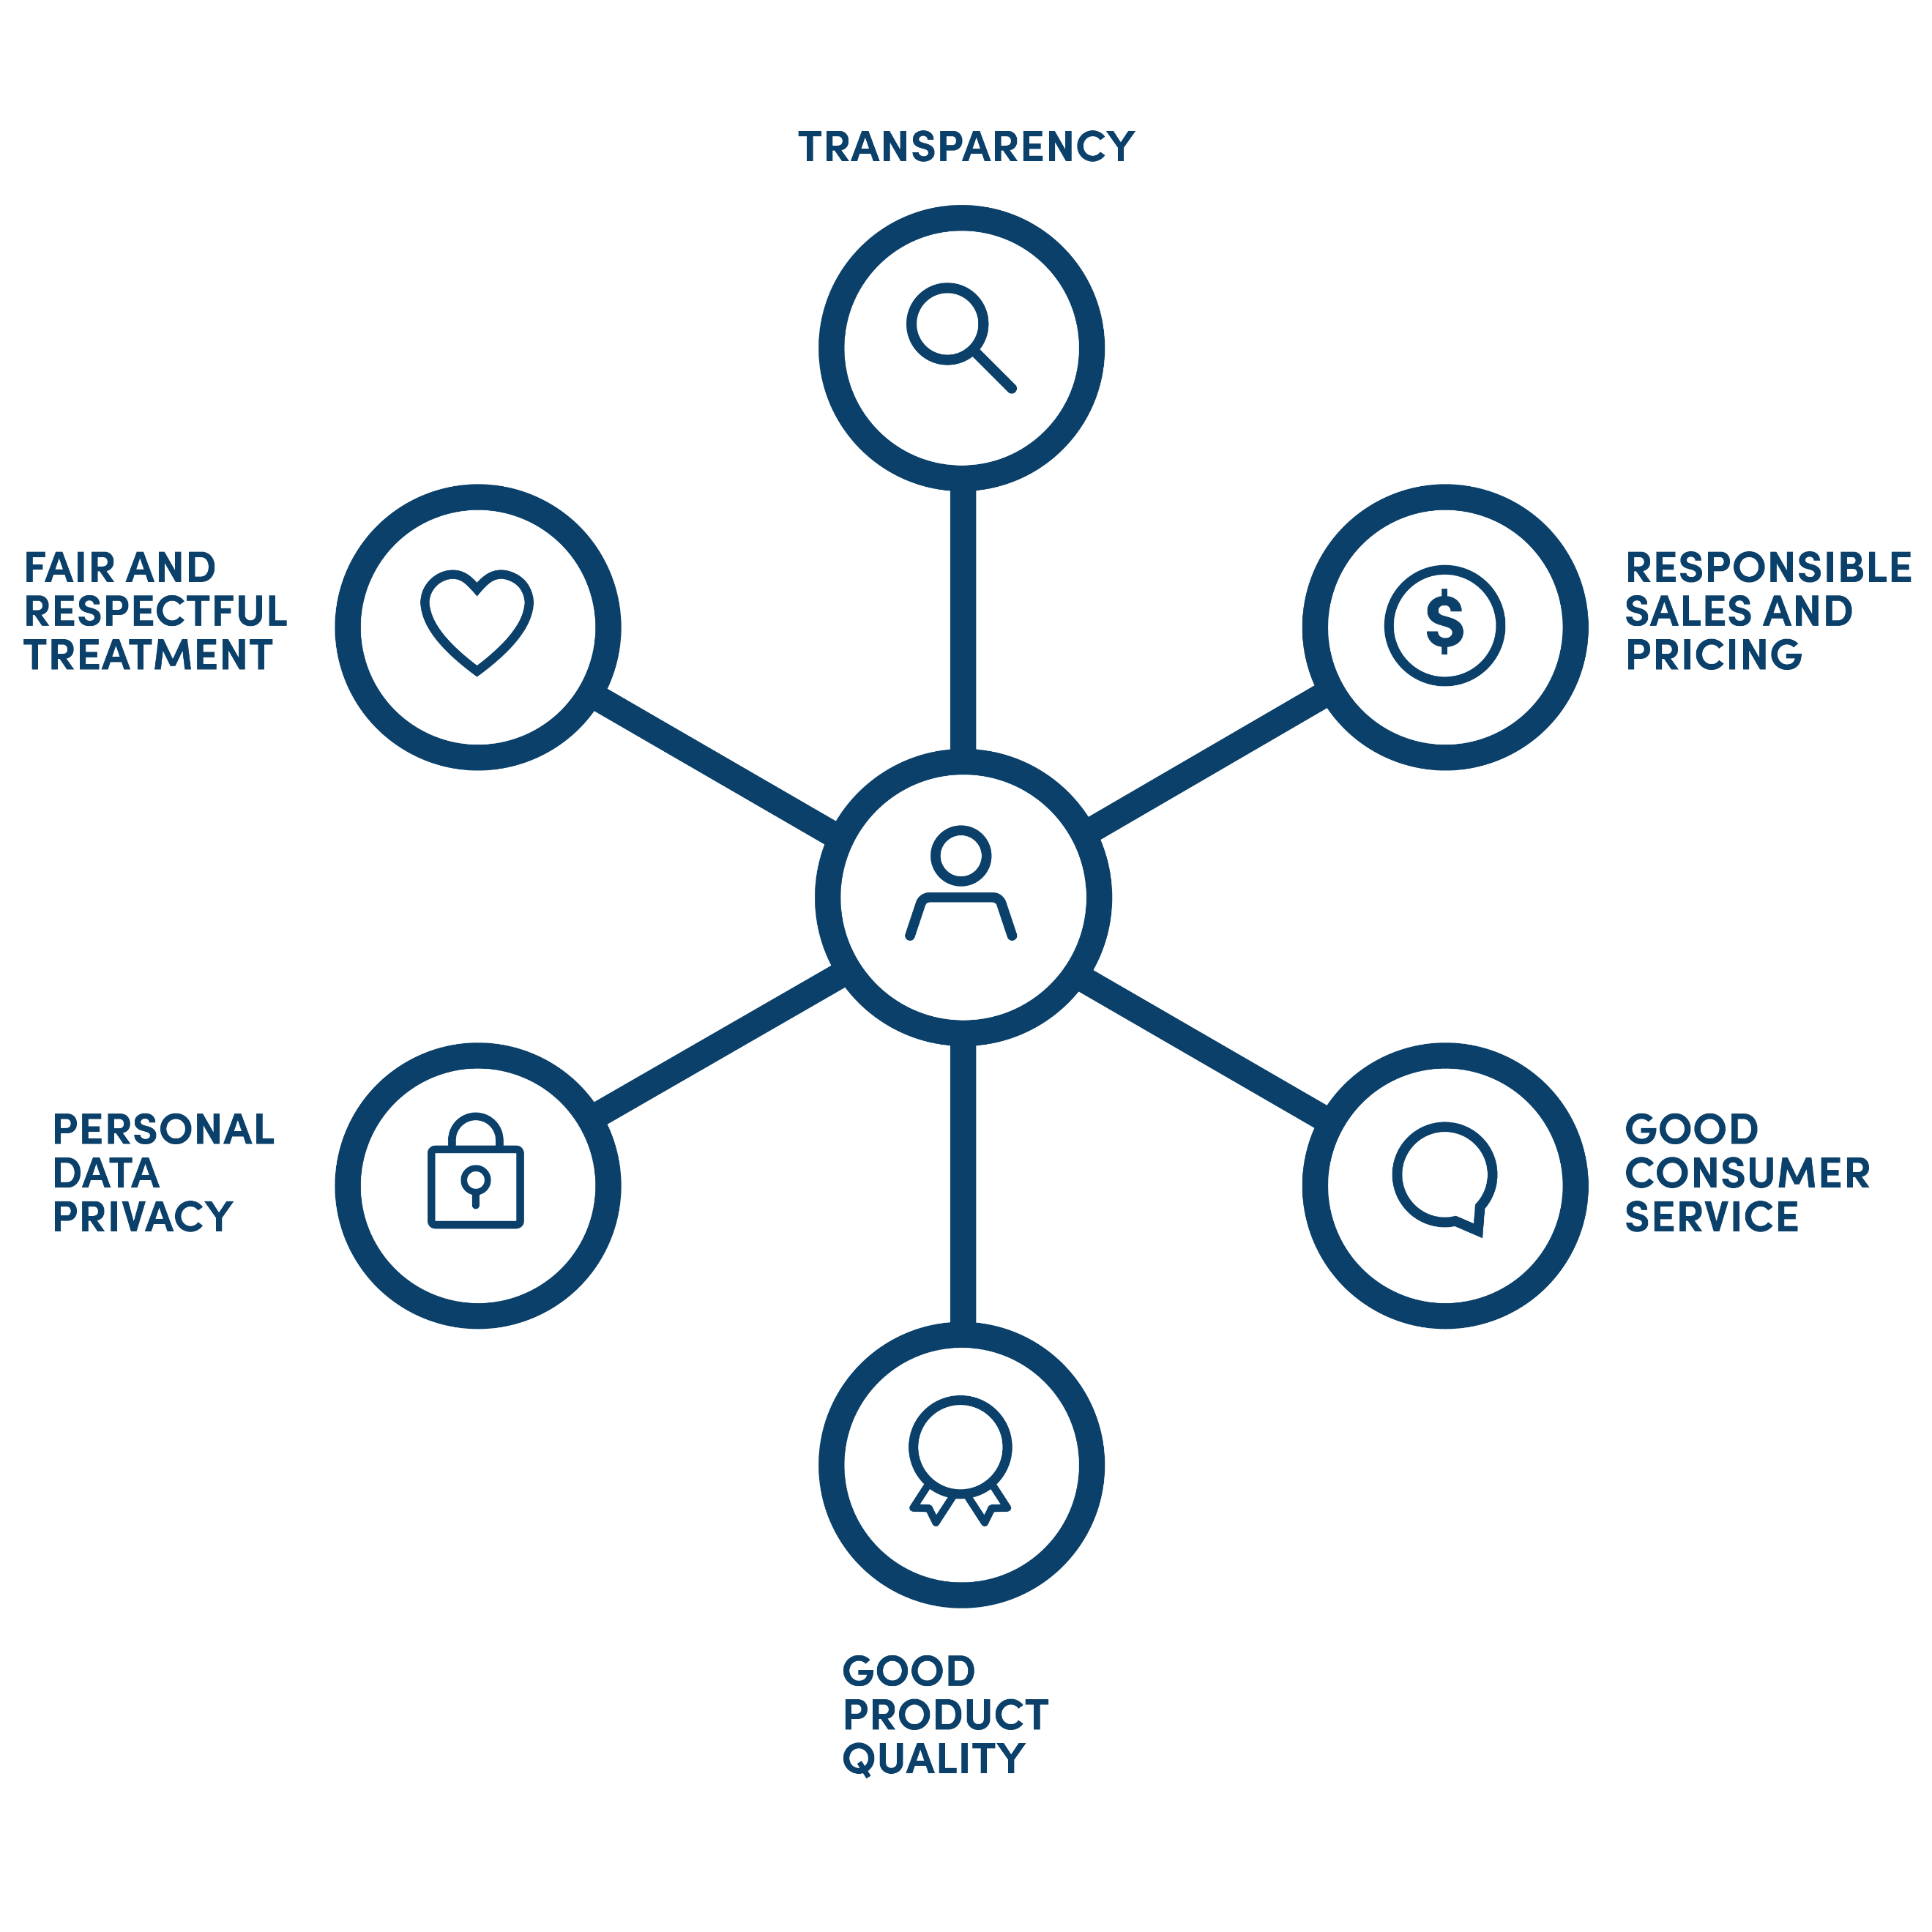
1) Discuss Pawame’s commitment to consumer protection and why it is good for the agent to follow the principles:
  - Aligned with our core value of customer-centricity
  - Better customer satisfaction
  - Better reputation for Pawame
  - More sales through referrals
  - Better repayment rates
  - The right thing to do!
2) Go through the practical actions related to each principle:
a) Transparency:
The agent should tell the customer:
      - What products we sell
      - How much the downpayment is for each one
    - How much the daily payment is for each one
    - What the total price of the product is
    - What happens if they don’t pay
    - What happens if they want to pay in cash

b) Responsible sales and pricing:
The agent should:
  - Ask the customer what kind of service the customer wants and very clearly state what level of service we can provide – e.g. don’t say we can power a fridge!
  - Tell the customer that they are expected to pay daily for the full loan term

c) Good customer service & Good product quality:
The agent should:
  - Tell the customer about in-home installation
  - Tell the customer about the warranties: 1 year for appliances, 3 years for critical components
  - Make sure the customer knows the toll-free number and warranty process
  - Tell the customer that eventually, when the product is completely out of use, Pawame will take it back for recycling and it should not be thrown into the environment

d) Fair and respectful treatment & Personal data privacy:
  - Each customer should be treated with the same respect and patience
  - Agents should be discreet with private customer information

